Bussing Management Written Report

In order to minimize costs, the optimal combination of students to send to each school would be:

* 245 poor students from District A to School 1
* 80 non-poor students from District A to School 1
* 75 non-poor students from District B to School 1
* 18 poor students from District A to School 2
* 250 poor students from District B to School 2
* 25 non-poor students from District B to School 2
* 207 non-poor students from District C to School 2
* 187 poor students from District A to School 3
* 20 poor students from District C to School 3
* 293 non-poor students from District C to School 3

Before fixed costs, this would result in a cost of $54192.  
After adding fixed costs, the cost would be $75192.

A) Lindo input for carpet cutting problem

MIN 24PA1 + 24NA1 + 32PB1 + 32 NB1 + 72PC1 + 72NC1 + 56PA2 + 56NA2 + 48PB2 + 48NB2 + 16PC2 + 16NC2 + 88PA3 + 88NA3 + 104PB3 + 104NB3 + 32PC3 + 32NC3

subject to

PA1 + PA2 + PA3 <= 450

NA1 + NA2 + NA3 <= 80

PB1 + PB2 + PB3 <= 250

NB1 + NB2 + NB3 <= 100

PC1 + PC2 + PC3 <= 20

NC1 + NC2 + NC3 <= 500

PA1 + NA1 + PB1 + NB1 + PC1 + NC1 <= 400

PA2 + NA2 + PB2 + NB2 + PC2 + NC2 <= 500

PA3 + NA3 + PB3 + NB3 + PC3 + NC3 <= 500

NA1 + NB1 + NC1 <= 234.4

NA1 + NB1 + NC1 >= 153.4

NA2 + NB2 + NC2 <= 293

NA2 + NB2 + NC2 >= 193

NA3 + NB3 + NC3 <= 293

NA3 + NB3 + NC3 >= 193

PA1 + PB1 + PC1 <= 245.6

PA1 + PB1 + PC1 >= 165.6

PA2 + PB2 + PC2 <= 307

PA2 + PB2 + PC2 >= 207

PA3 + PB3 + PC3 <= 307

PA3 + PB3 + PC3 >= 207

PA1 + NA1+ PA2+ NA2 + PA3 + NA3 + PB1 + NB1 + PB2 + NB2 + PB3 + NB3 + PC1 + NC1 + PC2 + NC2 + PC3 + NC3 = 1400

END

GIN PA1

GIN NA1

GIN PB1

GIN NB1

GIN PC1

GIN NC1

GIN PA2

GIN NA2

GIN PB2

GIN NB2

GIN PC2

GIN NC2

GIN PA3

GIN NA3

B) Lindo output for carpet cutting problem

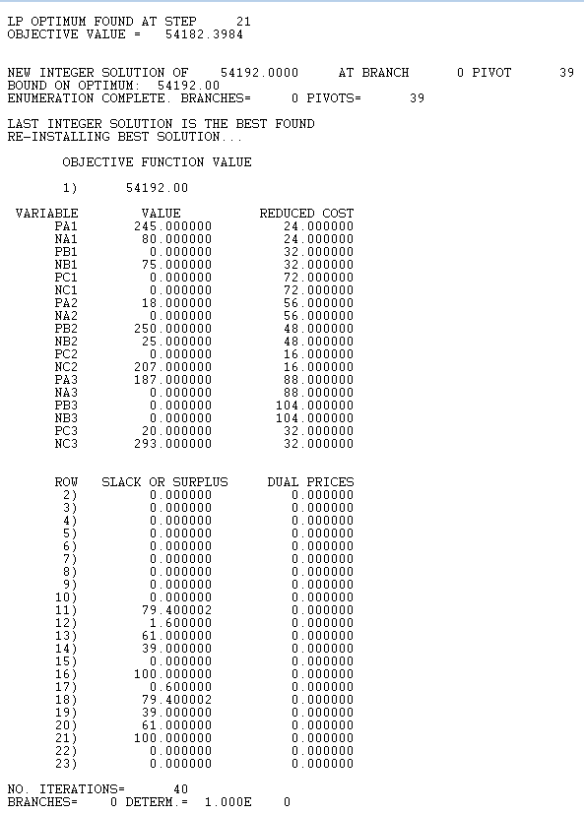

C) Constraints Testing

| Constraint | Proof of constraint being followed |
| --- | --- |
| All variables are forced integers | Figure B shows all variable values being whole numbers |
| PA1 + PA2 + PA3 <= 450 | 245 + 18 + 187 <= 450  450 <= 450 |
| NA1 + NA2 + NA3 <= 80 | 80 + 0 + 0 <= 80  80 <= 80 |
| PB1 + PB2 + PB3 <= 250 | 0 + 250 + 0 <= 250  250 <= 250 |
| NB1 + NB2 + NB3 <= 100 | 75 + 25 + 0 <= 100  100 <= 100 |
| PC1 + PC2 + PC3 <= 20 | 0 + 0 + 20 <= 20  20 <= 20 |
| NC1 + NC2 + NC3 <= 500 | 0 + 207 + 293 <= 500  500 <= 500 |
| PA1 + NA1 + PB1 + NB1 + PC1 + NC1 <= 400 | 245 + 80 + 0 + 75 + 0 + 0 <= 400  400 <= 400 |
| PA2 + NA2 + PB2 + NB2 + PC2 + NC2 <= 500 | 18 + 0 + 250 + 25 + 0 + 207 <= 500  500 <= 500 |
| PA3 + NA3 + PB3 + NB3 + PC3 + NC3 <= 500 | 187 + 0 + 0 + 0 + 20 + 293 <= 500  500 <= 500 |
| NA1 + NB1 + NC1 <= 234.4 | 80 + 75 + 0 <= 234.4  155 <= 234.4 |
| NA1 + NB1 + NC1 >= 153.4 | 80 + 75 + 0 >= 153.4  155 >= 153.4 |
| NA2 + NB2 + NC2 <= 293 | 0 + 25 + 207 <= 293  232 <= 293 |
| NA2 + NB2 + NC2 >= 193 | 0 + 25 + 207 >= 193  232 >= 193 |
| NA3 + NB3 + NC3 <= 293 | 0 + 0 + 293 <= 293  293 <= 293 |
| NA3 + NB3 + NC3 >= 193 | 0 + 0 + 293 >= 193  293 >= 193 |
| PA1 + PB1 + PC1 <= 245.6 | 245 + 0 + 0 <= 245.6  245 <= 245.6 |
| PA1 + PB1 + PC1 >= 165.6 | 245 + 0 + 0 >= 165.6  245 >= 165.6 |
| PA2 + PB2 + PC2 <= 307 | 18 + 250 + 0 <= 307  268 <= 307 |
| PA2 + PB2 + PC2 >= 207 | 18 + 250 + 0 >= 207  268 >= 207 |
| PA3 + PB3 + PC3 <= 307 | 187 + 0 + 20 <= 307  207 <= 307 |
| PA3 + PB3 + PC3 >= 207 | 187 + 0 + 20 >= 207  207 >= 207 |
| PA1 + NA1+ PA2+ NA2 + PA3 + NA3 + PB1 + NB1 + PB2 + NB2 + PB3 + NB3 + PC1 + NC1 + PC2 + NC2 + PC3 + NC3 = 1400 | 245 + 80 + 0 + 75 + 0 + 0 + 18 + 0 + 250 + 25 + 0 + 207 + 187 + 0 + 0 + 0 + 20 + 293 = 1400  1400 = 1400 |
| 24PA1 + 24NA1 + 32PB1 + 32 NB1 + 72PC1 + 72NC1 + 56PA2 + 56NA2 + 48PB2 + 48NB2 + 16PC2 + 16NC2 + 88PA3 + 88NA3 + 104PB3 + 104NB3 + 32PC3 + 32NC3 = 54,192 | 24(245) + 24(80) + 32(0) + 32(75) + 72(0) + 72(0) + 56(18) + 56(0) + 48(250) + 48(25) + 16(0) + 16(207) + 88(187) + 88(0) + 104(0) + 104(0) + 32(20) + 32(293) = 54,192  54,192 = 54,192 |